Steps to attach a Bond with Warrant

- On selecting “Approve Warrant” user should get below screen.
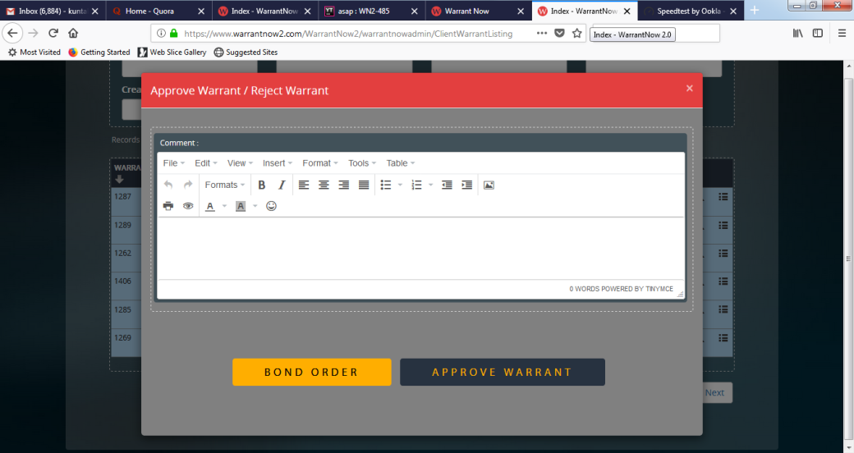
- To attach a bond user must click on  first and should see a screen similar to below screen.
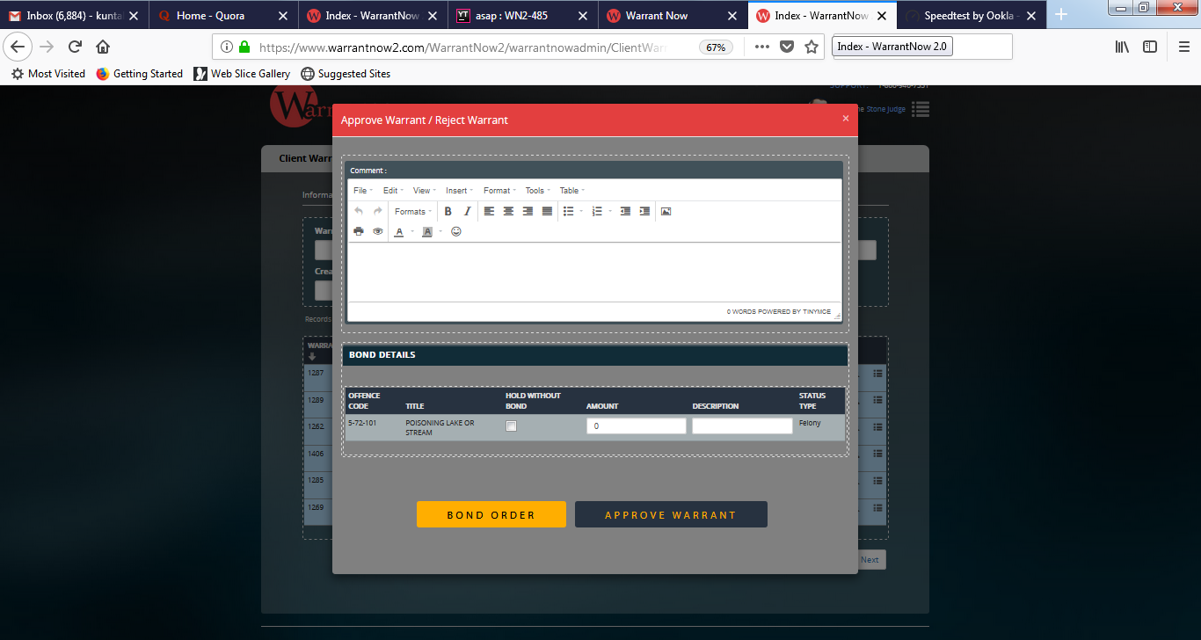
- Finally user should click on  to approve warrant with Bond.

